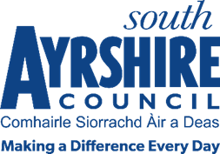

**Participatory Budgeting UK SPF 2025/2026**

### How to vote

1. Sign In or Register using your mygovscot, Facebook, Google account or register with the webpage using an existing email address.
2. When signed in, click Participatory Budgeting, and select Participatory Budgeting UK Shared Prosperity Fund 2025/2026.
3. Go to My Account in the top right-hand corner of the site and select the locality in which you live using the Geographic Area drop down list. Also verify your account details on this page. This will now give you access to your locality's voting page. If you have logged in using mygovscot you do not need to verify your account.
4. Now select the locality in which you wish to vote – note that you can only vote in one locality and should vote in the locality in which you live.
5. Read through each of the bids in your locality and decide which bids you wish to support.
6. Click ‘Vote’ on the bids you wish to support.
7. You can vote for up to five projects that you would like to see funded.
8. You can sign in again, using the same long-in details and amend your vote prior to the closing date on 4th July 2025.
9. If you have any issues with logging in or voting, you can contact us at [grants@south-ayrshire.gov.uk](mailto:grants@south-ayrshire.gov.uk).

