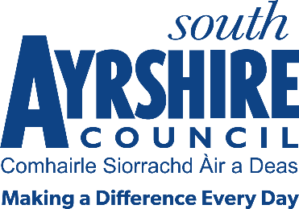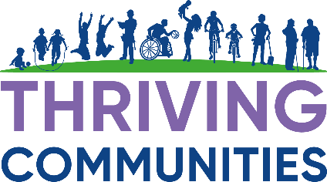

**Financial Inclusion Fund**

Guidance Notes & Essential Criteria

**Background**

South Ayrshire Council is committed to developing and supporting Financial Inclusion Projects that aim to help reduce poverty and improve the quality of life for our communities. The Local Outcome Improvement Plan (LOIP) states that “We are committed to reducing poverty within South Ayrshire and we will continue to work in partnership to help individuals and families access financial support services that will assist with fuel poverty, income maximisation and food insecurity. Partners will ensure local support is available that assists with the cost of living by ensuring advice, guidance and support services are accessible and available across South Ayrshire.

It is anticipated that these projects will aim to meet the following outcomes:

* Breaking the Cycle of debt & dependency
* Reducing Child Poverty
* A reduction in the number of people in crisis through early intervention
* Preparing people for employment, training, education & volunteering opportunities

**Why do we need to provide support?**

Low-income limits choice and restricts freedom; it can bring anxiety, stress, and uncertainty; it can be a contributory factor in family breakdown; it is a key driver in homelessness, crime, and addiction; and it can lead to significant health problems and widen health inequalities, particularly if experience of low income is long-term.

Currently in South Ayrshire there are:

* 7 (SIMD) data zones in the top 5% most deprived Index(SIMD is the Scottish Governments standard approach to identify multiple areas of deprivation)
* In 2022/23, South Ayrshire had the 11th highest child poverty rate (after housing costs) nationally and was above the Scottish average - 25% compared to 21.8%.   This is an estimate of 4,245 children (aged 0-15years) in South Ayrshire.
* In 2022/23, Trussell Trust distributed almost 7, 200 food parcels for adults/children throughout South Ayrshire.  There was a slight decrease from the previous year.
* Fuel Poverty is 26.1% compared to 23.8% nationally (2022/23 figures)
* 12.2% of South Ayrshire population is income deprived which is similar rate to Scotland 12.1%

**Groups more likely to experience low income:**

* Lone parent families
* Families with a disabled adult or child
* Larger families with three or more children
* Families with a child under one year old
* Minority ethnic families

**Funding Available**

Grants of up to £4950 are available for proposals that meet the purpose and criteria of the fund. There is no minimum grant amount. Applications can be for up to 100% of identified costs but the inclusion of any match funding in proposals will be looked upon favourably.

**Who can apply:**

**Groups and organisations** who are working directly with residents from low-income households can apply for this grant for capital costs. Applicants will be expected to show how the grant will improve the lives for these families.

**All applicants** must be active in our South Ayrshire Council’s area and spend any agreed funding such that it benefits residents/communities in South Ayrshire Council’s area.

**Third Sector organisations/community groups** require to have a constitution and appropriate governance and financial arrangements in place, proportionate to the value of the application.

**How to Apply**

The fund is open for applications until **Thursday 31st July 2025.**

Contact South Ayrshire Council for further information:

[**Grants@south-ayrshire.gov.uk**](mailto:Grants@south-ayrshire.gov.uk)

**Eligibility**

Applications must:

* detail the full project costs and can be for **capital** costs
* directly benefit South Ayrshire communities

**EXCLUSIONS**

Applications:

* **cannot** be from any South Ayrshire Council Service

**Awards Process**

An awards panel comprising of a representative from the CPP, Third Sector organisations and South Ayrshire Council officers, will review all applications and inform groups of the outcome of their submission.

The Award panel decisions are final, there is no appeals process.

Any monies awarded must be spent by the 31st March 2026.

Any unspent monies will be required to be returned. Any carry forward requests for after this did must be approved by the Service Lead Thriving Communities.

**Closing date**

The closing date for applications is **Thursday 31st July 2026.**

**Monitoring & Evaluating**

* All grants awarded will be subject to strict monitoring and evaluating procedure.
* A midterm revue may be carried out.
* Any changes to your proposed project, or any delay in spending then you must inform the grants officer immediately.
* An evaluation form will be issued on completion, and this must be returned**. All invoices/receipts and proof of payment need to be returned. Failure to return may result in you having to pay back your grant funding.**
* Any groups not submitting an evaluation form may not receive any future funding from South Ayrshire Council. You may also be asked to repay the grant if you are not able to provide satisfactory evidence that the grant has been spent for the intended purpose.